***USE CASE DIAGRAM:*** 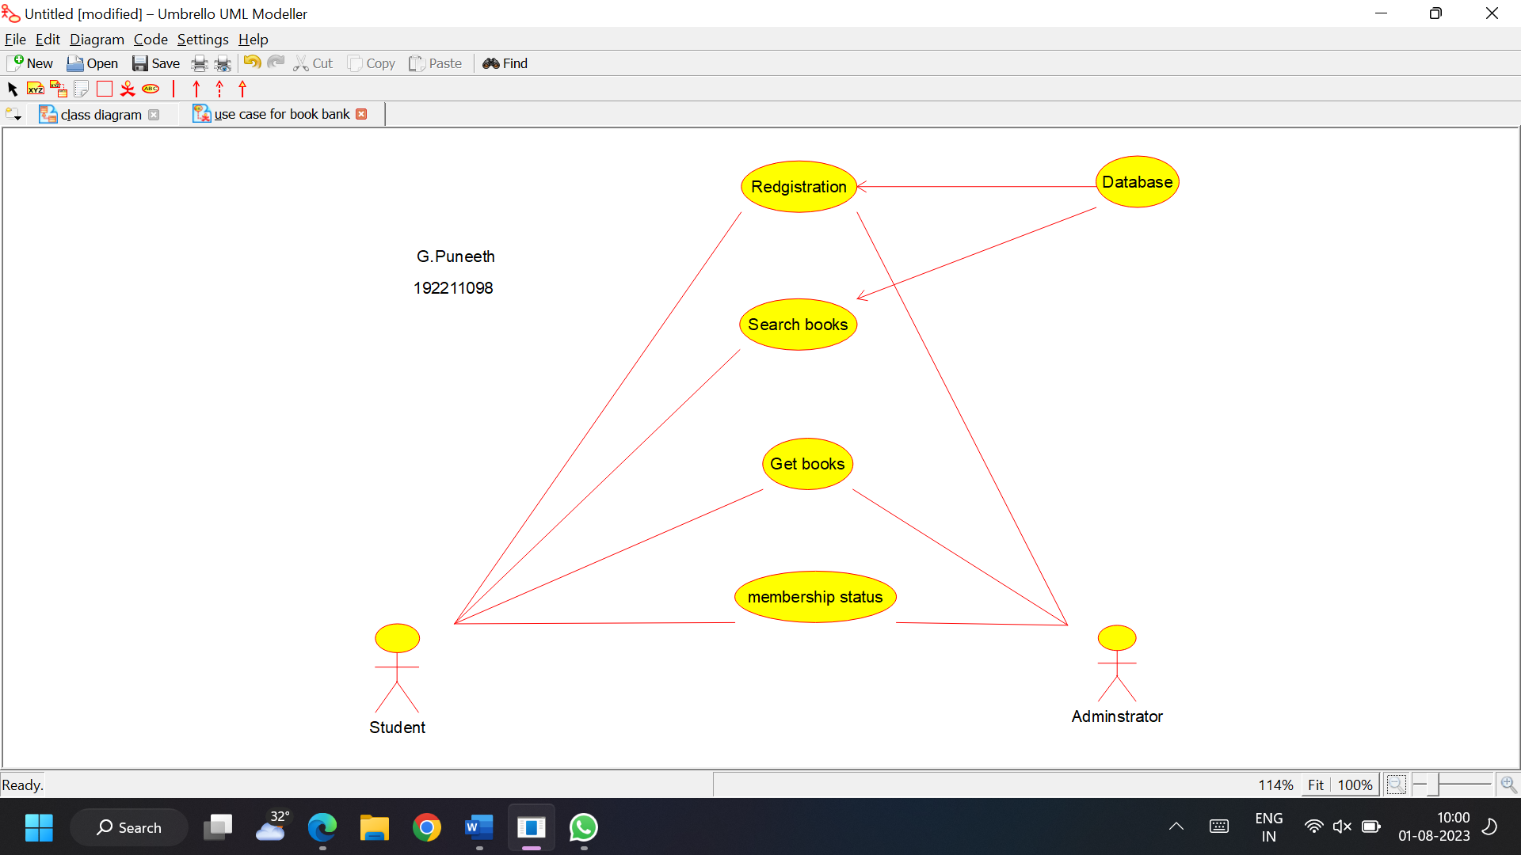

***CLASS DIAGRAM:***

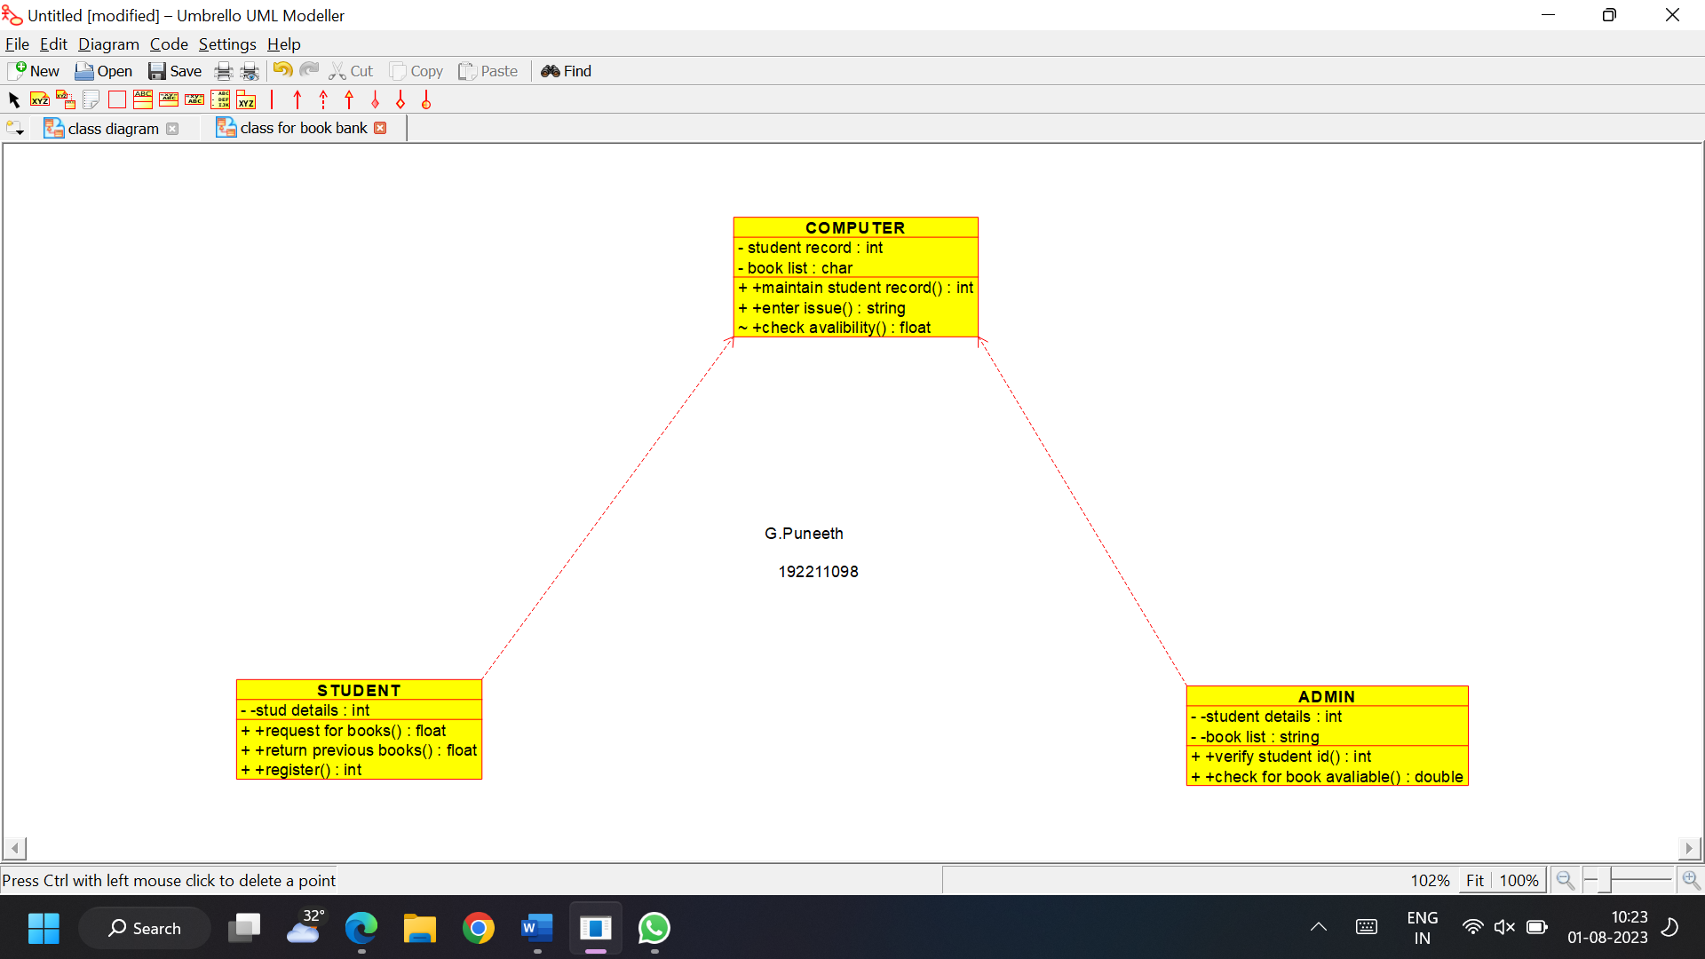

***ACTIVITY DIAGRAM:***

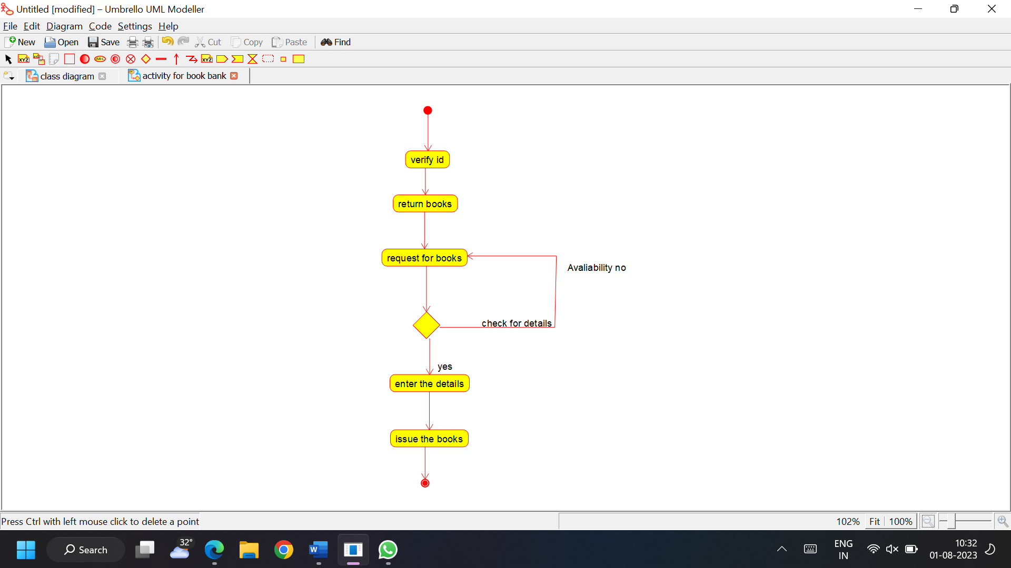

***STATE CHART DIAGRAM:***

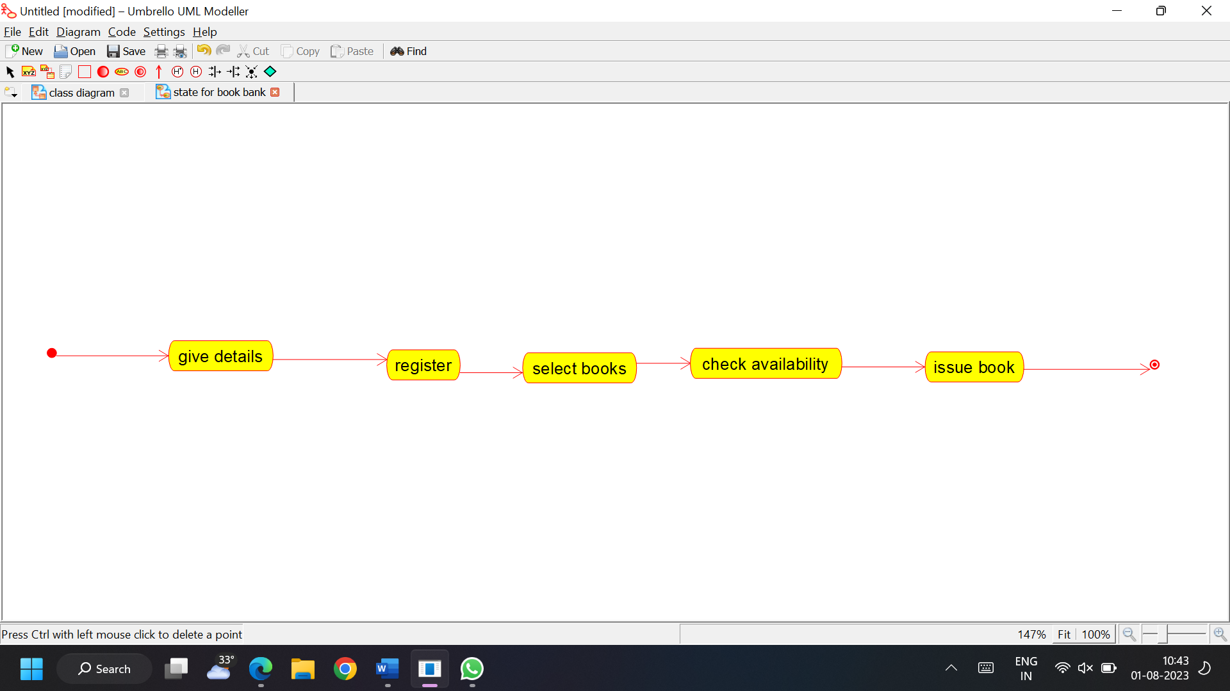

***SEQUENCE DIAGRAM:***

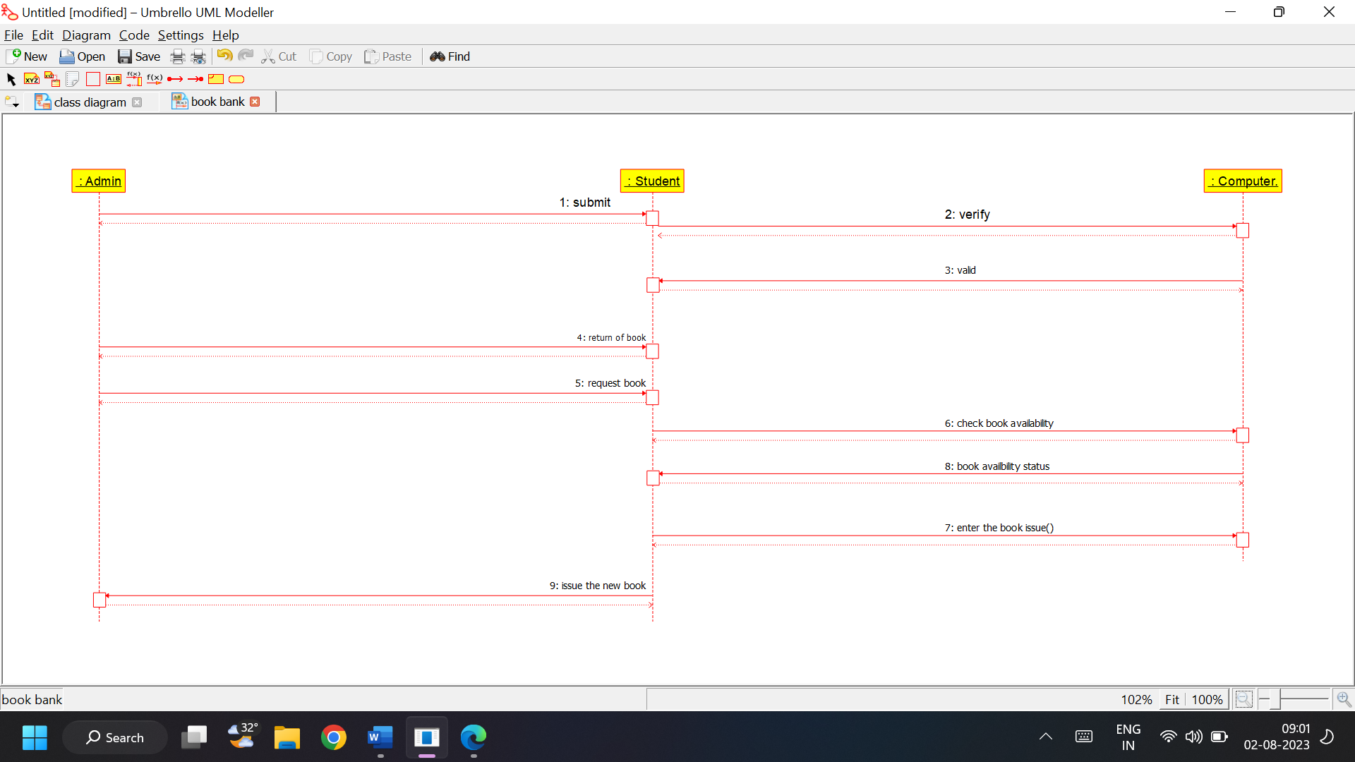

***COMMUNICATION DIAGRAM:***

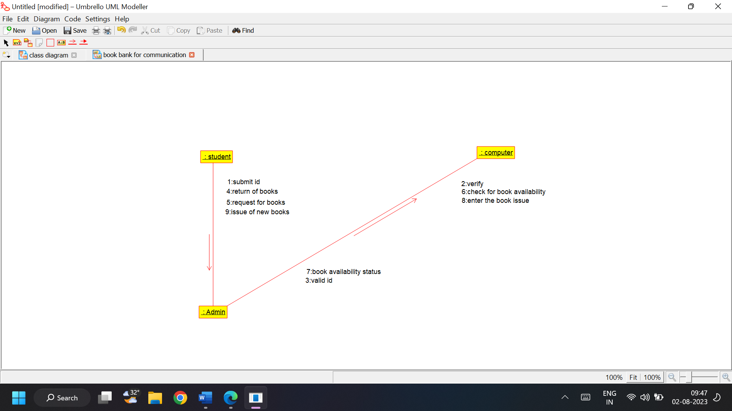

***COMPONENT DIAGRAM:***

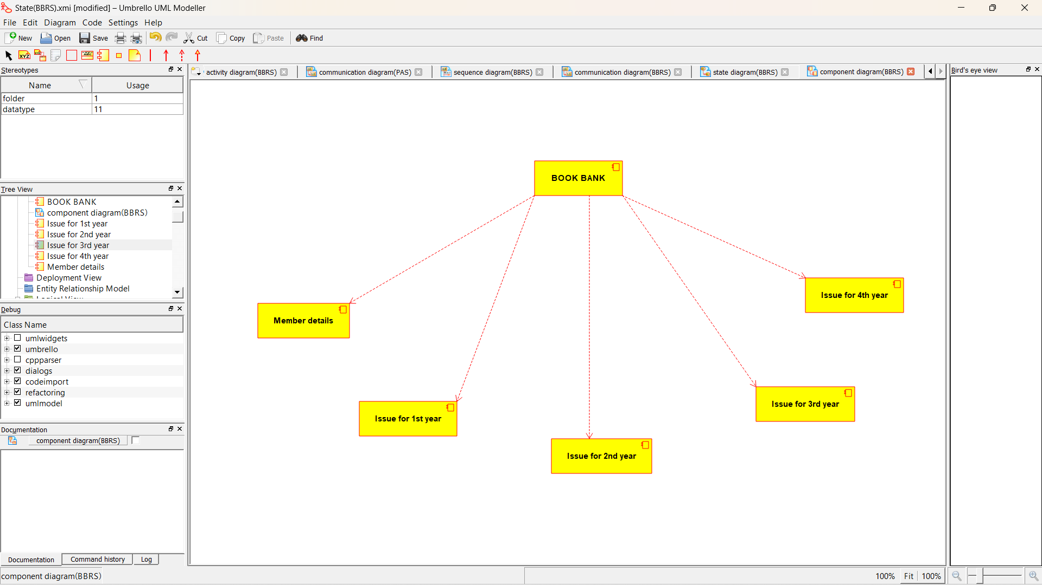

***DEPLOYMENT DIAGRAM:***

